**DSP Lab Assignment**

Submitted By  **Md. Fahim Shahriar (154440)**

**Task 1**

**Code :**

r = 0.9;

theta = pi/10;

x = [];

real = [];

img = [];

for i = -100:.5:20

x = [x i];

val = r ^ i;

real = [real val * cos(i * theta)];

img = [img val * sin(i * theta)];

end

subplot(2,1,1);

plot(x,real);

title('Real Part');

xlabel('values of n');

ylabel('x(n)');

grid on;

subplot(2,1,2);

plot(x,img);

title('Imaginary Part');

xlabel('values of n');

ylabel('x(n)');

grid on;

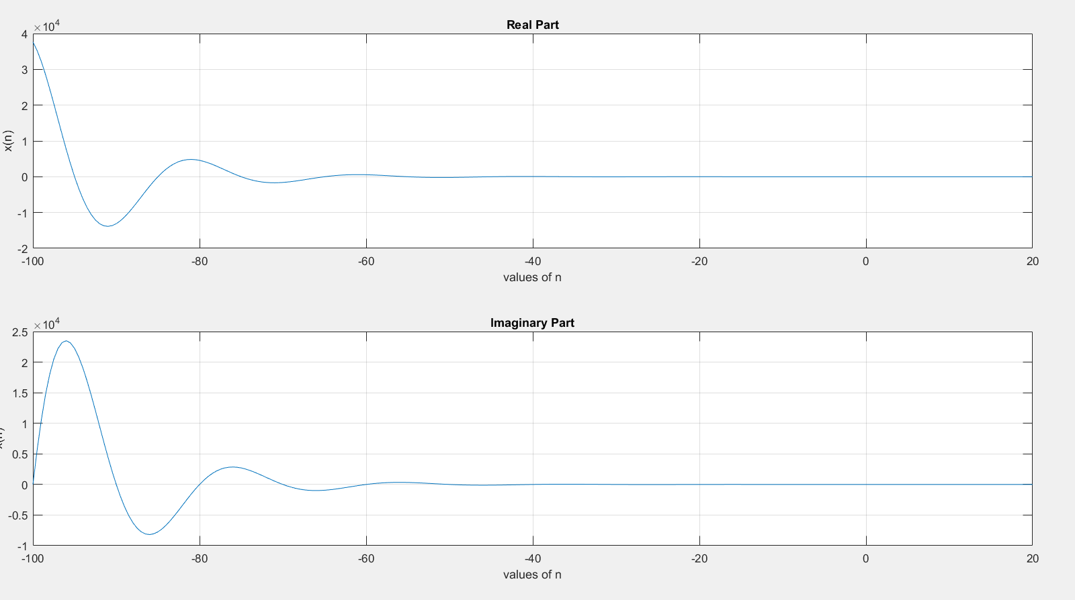**Figure :**

**Task 2**

**Code :**

subplot(2,2,4);

a = -1.5;

x1 = [];

y1 = [];

for n = 0 : .1 : 10

x1 = [x1 n];

y1 = [y1 a^n];

end

plot(x1,y1);

title('a < -1');

xlabel('values of n');

ylabel('x(n)');

grid on;

subplot(2,2,1);

a = 0.5;

x1 = [];

y1 = [];

for n = 0 : .5 : 10

x1 = [x1 n];

y1 = [y1 a^n];

end

plot(x1,y1);

title('0 < a < 1');

xlabel('values of n');

ylabel('x(n)');

grid on;

subplot(2,2,2);

a = 1.5;

x1 = [];

y1 = [];

for n = 0 : .5 : 10

x1 = [x1 n];

y1 = [y1 a^n];

end

plot(x1,y1);

title('a > 1');

xlabel('values of n');

ylabel('x(n)');

grid on;

subplot(2,2,3);

a = -0.5;

x1 = [];

y1 = [];

for n = 0 : .1 : 10

x1 = [x1 n];

y1 = [y1 a^n];

end

plot(x1,y1);

title('-1 < a < 0');

xlabel('values of n');

ylabel('x(n)');

grid on;

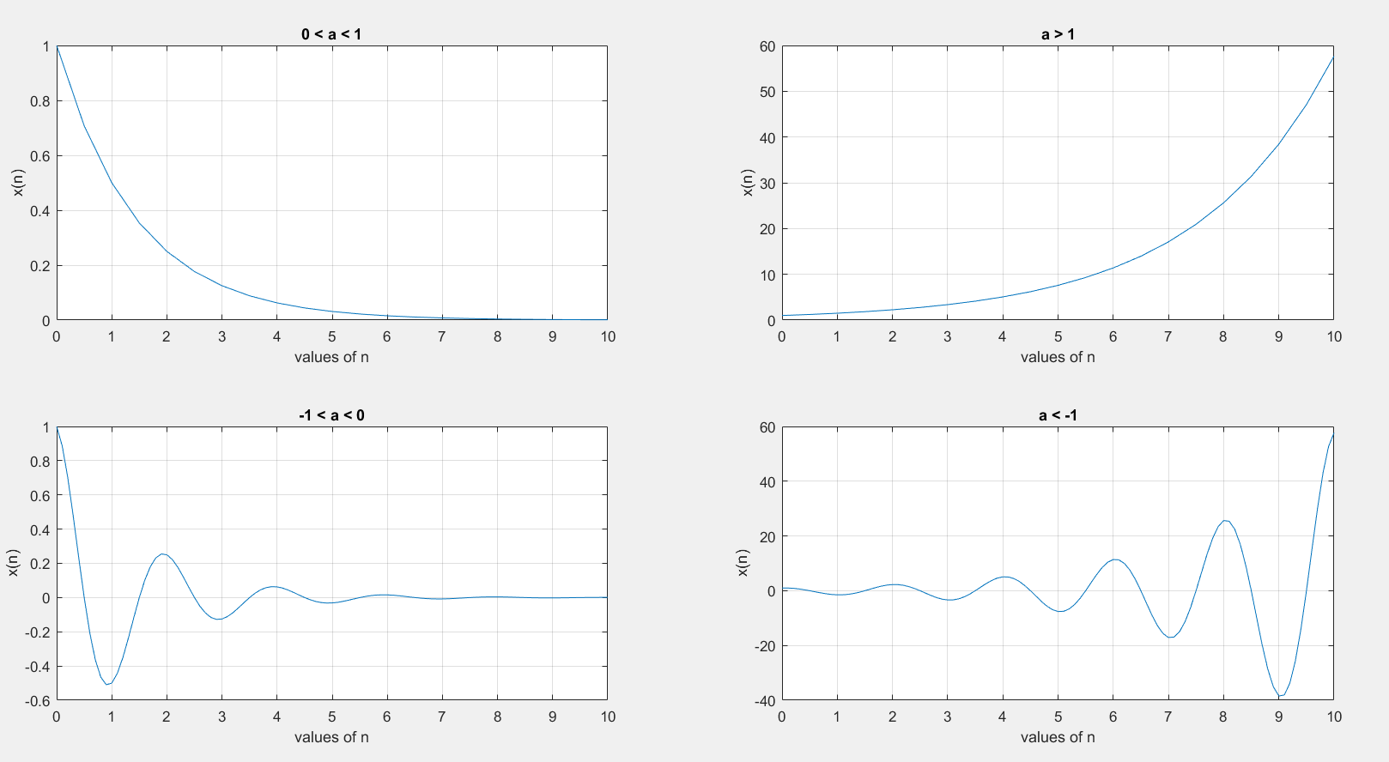**Figure :**

**Task 3**

**Code:**

A = 1.5;

Values = [0 .1 .2 .8 .9 1 1.1 1.2];

for in = 1 : 8

omega = pi * Values(in);

x = [];

y = [];

for n = 0 : 40

x = [x n];

y = [y A * cos(omega * n)];

end

subplot(4,2,in);

stem(x,y);

title(['\omega = ',num2str(Values(in)) ,'\pi']);

xlabel('n');

ylabel('x(n)');

ylim([-1.5 1.5]);

yticks(-1.5:1.5:1.5);

end

**Figure :**

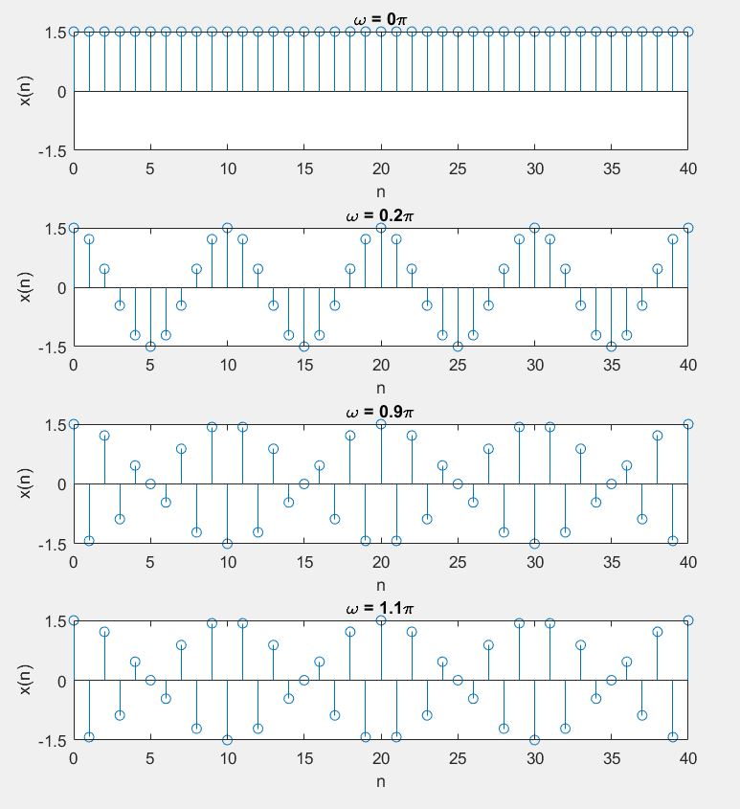

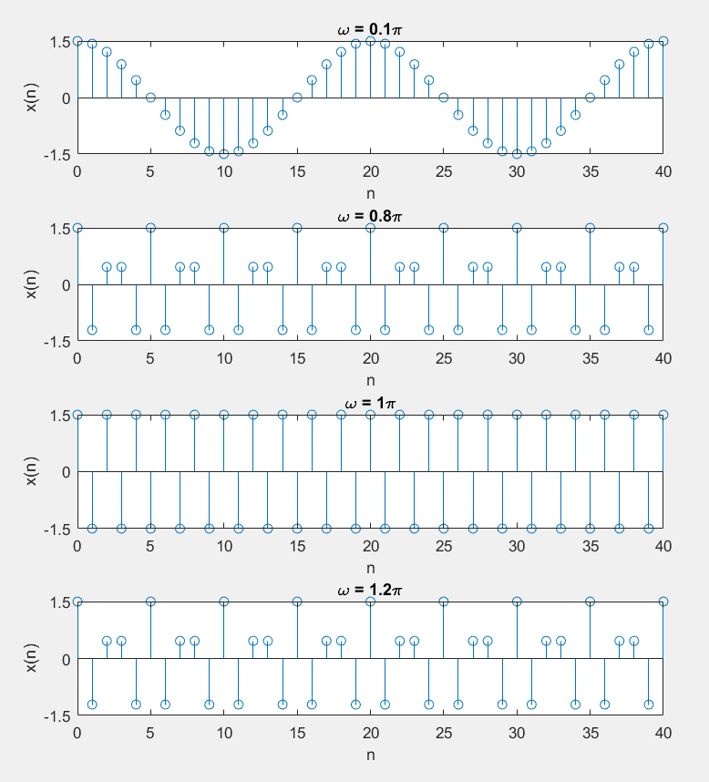

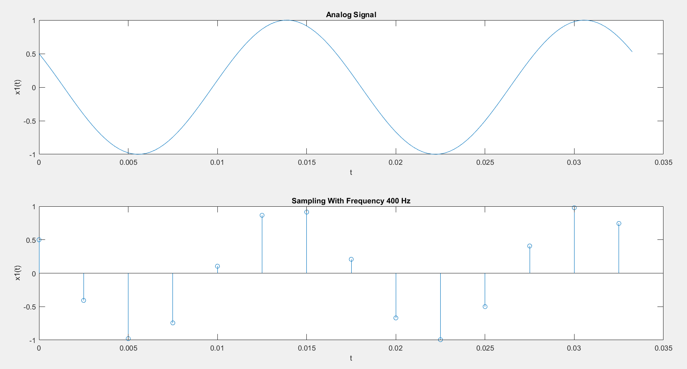**Task 4**

**Figure 1:**

**Code 1:**

subplot(2,1,1);

t = 0:1/4000:2/60;

plot(t,cos(120 * pi * t + pi/3));

xlabel('t');

ylabel('x1(t)');

title('Analog Signal');

subplot(2,1,2);

t = 0:1/400:2/60;

stem(t,cos(120 * pi * t + pi/3));

xlabel('t');

ylabel('x1(t)');

title('Sampling With Frequency 400 Hz');

**Let us take two more signals and such that and . We will plot the signals and sample them with considering sampling frequency 400 Hz.**

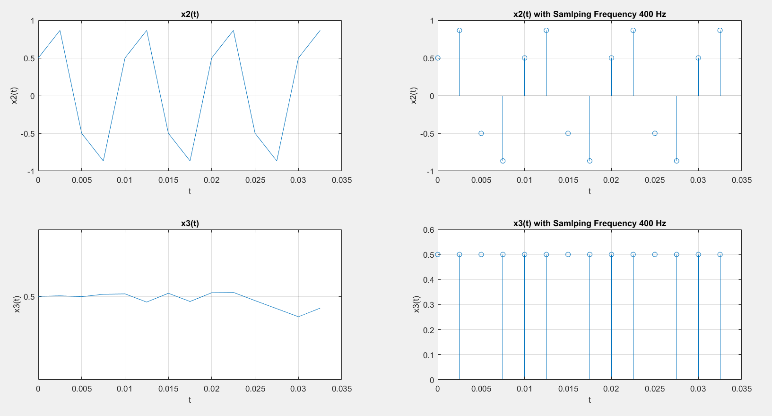

According to the Nyquist Theorem, the sampling rate must be at least , or twice the highest analog frequency component.

If the sampling rate is less than , some of the highest frequency components in the analog input signal will not be correctly represented in the digitized output. When such a digital signal is converted back to analog form by a digital-to-analog converter, false frequency components appear that were not in the original analog signal. This undesirable condition is a form of distortion called **aliasing**.

In both , the effect of aliasing have been noticed. In the negative part has totally been lost because of aliasing.